

Data Structures And Algorithms
( Course Code: CSC211 )

Name : Muhammad Abdullah
Roll No # FA24-BSE-042
Instructor Name : Sir Atique

Assignment # 3
Lab Part

Question #1:
PART – A: THEORY SECTION A technology company, TechTree Inc., has grown significantly and wants to digitally represent its hierarchical structure as a Full Binary Tree to optimize internal operations. • The CEO is at the root of the hierarchy. • Each Manager supervises exactly two Team Leads. • Each Team Lead supervises exactly two Developers. • This creates a Full Binary Tree, where every non-leaf node has exactly two children. TechTree Inc. provides two data files for reconstructing the hierarchy: 1. Preorder Traversal File: Lists employees starting from the root (CEO) and traversing top-down, left to-right. Example content: ["CEO", "Manager1", "TeamLead1", "Developer1", "Developer2", "TeamLead2", "Developer3", "Developer4", "Manager2", ...] 2. Postorder Traversal File: Lists employees based on project completion, traversing bottom-up, left-to right. Example content: ["Developer1", "Developer2", "TeamLead1", "Developer3", "Developer4", "TeamLead2", "Manager1", "Manager2", "CEO"] Q1 (Theory): Reconstruct Full Binary Tree from Traversals (a) Write a step-by-step algorithm to reconstruct the Full Binary Tree from the given preorder and postorder traversals. (b) Ensure your algorithm enforces the Full Binary Tree property, i.e., every node has either 0 or 2 children. (c) Explain how the reconstructed tree represents the hierarchical structure of TechTree Inc., including CEO, Managers, Team Leads, and Developers. Note: Only algorithm design and theoretical explanation are required. No coding is needed in this part. PART – B : LAB / PROGRAMMING SECTION Q2 (Lab): C++ Program – Full Binary Tree Reconstruction Write a C++ program that: 1. Reads the preorder and postorder traversal data of TechTree Inc.’s hierarchy. 2. Reconstructs the Full Binary Tree using the provided traversals. 3. Ensures the resulting tree satisfies the Full Binary Tree property (every non-leaf node has exactly 2 children). 4. Displays the reconstructed tree in level-order traversal or any clear tree format showing the hierarchy (CEO → Managers → Team Leads → Developers). Requirements / Restrictions: • Use structs or classes for tree nodes. • Use pointers for left and right children. • Clearly comment the code and provide sample output showing the hierarchy.

CODE
#include <iostream>
#include <queue>
#include <string>
#include <vector>
using namespace std;

struct Node {
string name;
Node *left;
Node *right;

Node(string n){
name=n;
left=right=nullptr;
}
};
Node *buildTree(vector<string> &preorder, vector<string> &postorder,
int &preIndex, int postStart, int postEnd) {

//1st consition is for leftsubtree and second condition becomes true in case of right subtree post start and post end both are 7
if (preIndex >= preorder.size() || postStart > postEnd)
return nullptr;

// Create current root using preorder
Node *root = new Node(preorder[preIndex]);
preIndex++; // Move to next element in preorder

// If only one element exists in this postorder segment → leaf node
if (postStart == postEnd)
return root;

// The next element in preorder is always root of left subtree
string leftSubtreeRoot = preorder[preIndex];

// Search for this element in postorder to determine left subtree boundary
int index = -1;
for (int i = postStart; i <= postEnd; i++) {
if (postorder[i] == leftSubtreeRoot) {
index = i;
break;
}
}

// Recursively build left subtree (from postStart to index)
root->left = buildTree(preorder, postorder, preIndex, postStart, index);

// Recursively build right subtree (index+1 to postEnd-1)
root->right =
buildTree(preorder, postorder, preIndex, index + 1, postEnd - 1);

return root;
}

void printLevelOrder(Node *root) {
if (!root)
return;

queue<Node *> q;
q.push(root);

while (!q.empty()) {
int levelSize = q.size();

while (levelSize--) {
Node *current = q.front();
q.pop();

cout << current->name << " ";

if (current->left)
q.push(current->left);
if (current->right)
q.push(current->right);
}
cout << endl;
}
}

int main() {

vector<string> preorder = {"CEO", "Manager1", "TeamLead1",
"Dev1", "Dev2", "TeamLead2",
"Dev3", "Dev4", "Manager2"};

vector<string> postorder = {"Dev1", "Dev2", "TeamLead1",
"Dev3", "Dev4", "TeamLead2",
"Manager1", "Manager2", "CEO"};

int preIndex = 0;

Node *root =
buildTree(preorder, postorder, preIndex, 0, postorder.size() - 1);

cout << "Company Hierarchy (Level Order):\n";
printLevelOrder(root);

return 0;
}

OUTPUT
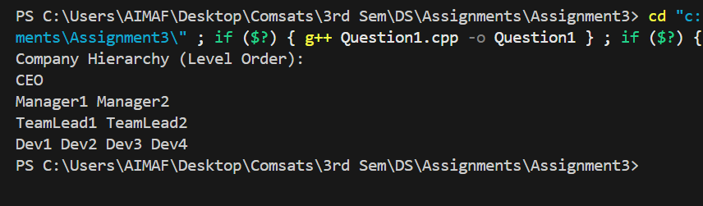

Question #2:
PART – A: THEORY SECTION A real-estate management company, HomeLink Solutions, manages a large database of properties. Each node in their current binary tree represents a property with the following details: • Property ID: A unique integer identifier for the property • Location: City or state of the property • Price: Current market price The binary tree is organized to allow efficient searching based on Property ID (smaller IDs in the left subtree, larger IDs in the right subtree). As the company scales, they want a simpler way to generate sorted property listings and perform range queries (e.g., find properties within a price range). To achieve this, they plan to convert the binary tree into a Doubly Linked List (DLL) following in-order traversal, so that the properties are arranged in ascending order of Property ID. Q1 (Theory): Binary Tree to Doubly Linked List Conversion (a) Write a step-by-step algorithm to convert the given binary tree into a Doubly Linked List (DLL) using in-order traversal. (b) Explain how the algorithm maintains the sorted order based on Property ID. (c) Describe how the DLL can be traversed in both forward and reverse directions to print all property details in ascending and descending order. Note: Only algorithm design and theoretical explanation are required. No coding needed in this part. PART – B : LAB / PROGRAMMING SECTION Q2 (Lab): C++ Program – Binary Tree to Doubly Linked List Write a C++ program that: 1. Builds the binary tree with properties (Property ID, Location, Price). 2. Converts the binary tree into a Doubly Linked List (DLL) using in-order traversal. 3. Ensures the DLL maintains sorted order based on Property ID. 4. Implements functions to print the DLL: o Forward traversal: Display all property details in ascending order of Property ID o Reverse traversal: Display all property details in descending order of Property ID Requirements / Restrictions: • Do not use STL list or pre-built DLL libraries; implement DLL manually using structs or classes. • Use pointers for left/right or previous/next links. • Include sample outputs showing forward and reverse traversals of the DLL.

CODE

#include <iostream>
using namespace std;

class Node {
public:
int id;
string location;
int price;
Node* left;
Node* right;

Node(int i, string l, int p) {
id = i;
location = l;
price = p;
left = right = nullptr;
}
};

class BST {
public:
Node* root;
Node* prev;
Node* head;

BST() {
root = nullptr;
prev = nullptr;
head = nullptr;
}

void insert(Node* &root, int i, string l, int p) {
if (root == nullptr) {
root = new Node(i, l, p);
return;
}
if (i < root->id) {
insert(root->left, i, l, p);
} else if (i == root->id) {
cout << "Duplicates not allowed" << endl;
return;
} else {
insert(root->right, i, l, p);
}
}

void flatenInDll(Node* root) {
if (root == nullptr) return;
//performaing in order traversal to flatten B S tree in dll which naturally maintains sorted order
flatenInDll(root->left);

if (prev == nullptr) {
head = root;
} else {
root->left = prev;
prev->right = root;
}

prev = root;
flatenInDll(root->right);
}

// forward traversal of DLL
void forwardTraversal(Node* head) {
Node* temp = head;
while (temp != nullptr) {
cout << temp->id << " " << temp->location << " " << temp->price << endl;
temp = temp->right;
}
}

// reverse traversal of DLL
void reverseTraversal(Node* head) {
if (head == nullptr) return;

Node* temp = head;

// move to last node of DLL
while (temp->right != nullptr) {
temp = temp->right;
}

// now go backwards
while (temp != nullptr) {
cout << temp->id << " " << temp->location << " " << temp->price << endl;
temp = temp->left;
}
}
};

int main() {
BST tree;

// inserting nodes in BST
tree.insert(tree.root, 4, "Lahore", 500);
tree.insert(tree.root, 2, "Karachi", 200);
tree.insert(tree.root, 6, "Islamabad", 600);
tree.insert(tree.root, 1, "Multan", 100);
tree.insert(tree.root, 3, "Pindi", 300);
tree.insert(tree.root, 5, "Faisalabad", 450);
tree.insert(tree.root, 7, "Quetta", 700);

// flatten BST into DLL
tree.flatenInDll(tree.root);

cout << "Forward DLL Traversal:" << endl;
tree.forwardTraversal(tree.head);

cout << "\nReverse DLL Traversal:" << endl;
tree.reverseTraversal(tree.head);

return 0;
}

OUTPUT
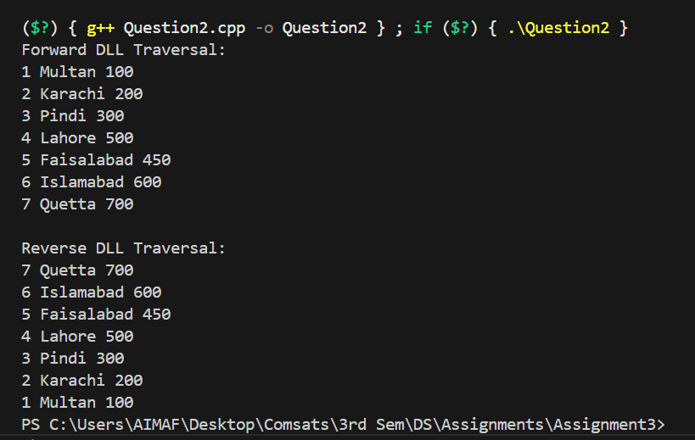

Question # 3
A company processes real-time sales data. Each transaction contains the following fields: transactionID, productName, amount, and timestamp. A subset of these transactions is stored in a Binary Search Tree (BST) using the amount as the key. The BST is constructed using the following transaction amounts: 4500, 2200, 5000, 1800, 3000, 4700, 5100, 2600, 1900 Page 4 FA2025 FA2025 Page 5 Q1 (Theory): BST Deletion and AVL Conversion Due to a customer refund and a manual correction, the transactions having amounts 3000 and 5000 must be deleted from the BST. (a) Draw the original BST using the provided transaction amounts. (b) Delete the nodes with 3000 and 5000, and draw the updated BST. (c) Convert the updated BST into a balanced AVL Tree (theory only). Draw the final AVL Tree structure after applying the necessary rotations. Note: AVL implementation in code is not required. Only theoretical diagrams are needed. PART – B: LAB / PROGRAMMING SECTION Q2 (Lab): BST Implementation in C++ Write a C++ program to: • Build the BST using the given transaction amounts • Delete the nodes with amounts 3000 and 5000 • Display the BST before and after the deletion operations Q3 (Lab): Max Heap and Descending Sort in C++ To analyze high-value transactions, the company wants the transaction amounts arranged in descending order. Write a C++ program to: • Build a Max Heap using the transaction amounts remaining after the BST deletions • Perform Heap Sort to arrange the values in descending order • Display the sorted transaction amounts Restrictions: • Do not use STL sort() • Do not use priority_queue or STL heap functions • Implement heap operations manually (heapify, insert, delete, heap-sort)

CODE
#include <iostream>
#include <vector>
using namespace std;

class Node {
public:
int id;
string productName;
int amount;
string timeStamp;
Node* left;
Node* right;

Node(int i, string pN, int a, string tS) {
id = i;
productName = pN;
amount = a;
timeStamp = tS;
left = right = nullptr;
}
};

class BST {
public:
Node* root;

BST() {
root = nullptr;
}

// Insert node using amount as key
void insert(Node*& root, int i, string pN, int a, string tS) {
if (root == nullptr) {
root = new Node(i, pN, a, tS);
return;
}
if (a < root->amount)
insert(root->left, i, pN, a, tS);
else
insert(root->right, i, pN, a, tS);
}

// Inorder traversal
void inOrder(Node* root) {
if (!root) return;
inOrder(root->left);
cout << root->id << " " << root->productName << " " << root->amount << " " << root->timeStamp << endl;
inOrder(root->right);
}

// Get inorder successor
Node* getSuccessor(Node* root) {
Node* temp = root;
while (temp && temp->left != nullptr)
temp = temp->left;
return temp;
}

// Delete node by amount
Node* deleteNode(Node* root, int amount) {
if (root == nullptr) return nullptr;

if (amount < root->amount) {
root->left = deleteNode(root->left, amount);
}
else if (amount > root->amount) {
root->right = deleteNode(root->right, amount);
}
else {
// Case 1: No child
if (!root->left && !root->right) {
delete root;
return nullptr;
}

// Case 2: One child
else if (!root->left) {
Node* temp = root->right;
delete root;
return temp;
}
else if (!root->right) {
Node* temp = root->left;
delete root;
return temp;
}

// Case 3: Two children
Node* succ = getSuccessor(root->right);
root->amount = succ->amount;
root->right = deleteNode(root->right, succ->amount);
}
return root;
}

// Extract amounts to array
void extract(Node* root, vector<int>& arr) {
if (!root) return;
extract(root->left, arr);
arr.push_back(root->amount);
extract(root->right, arr);
}

// Heapify (Max)
void heapifyDown(vector<int>& arr, int n, int i) {
int left = 2 * i + 1;
int right = 2 * i + 2;
int largest = i;

if (left < n && arr[left] > arr[largest])
largest = left;

if (right < n && arr[right] > arr[largest])
largest = right;

if (largest != i) {
swap(arr[i], arr[largest]);
heapifyDown(arr, n, largest);
}
}

// Build max heap
void buildMaxHeap(vector<int>& arr) {
int n = arr.size();
for (int i = n / 2 - 1; i >= 0; i--)
heapifyDown(arr, n, i);
}

// Heap Sort (ascending)
void heapSort(vector<int>& arr) {
int n = arr.size();
buildMaxHeap(arr);

for (int i = n - 1; i >= 1; i--) {
swap(arr[0], arr[i]);
heapifyDown(arr, i, 0);
}
}
};

int main() {
BST tree;

// Insert transactions
tree.insert(tree.root, 1, "ProductA", 4500, "2025-11-30 10:00");
tree.insert(tree.root, 2, "ProductB", 2200, "2025-11-30 10:05");
tree.insert(tree.root, 3, "ProductC", 5000, "2025-11-30 10:10");
tree.insert(tree.root, 4, "ProductD", 1800, "2025-11-30 10:15");
tree.insert(tree.root, 5, "ProductE", 3000, "2025-11-30 10:20");
tree.insert(tree.root, 6, "ProductF", 4700, "2025-11-30 10:25");
tree.insert(tree.root, 7, "ProductG", 5100, "2025-11-30 10:30");
tree.insert(tree.root, 8, "ProductH", 2600, "2025-11-30 10:35");
tree.insert(tree.root, 9, "ProductI", 1900, "2025-11-30 10:40");

cout << "\nBST Before Deletion:\n";
tree.inOrder(tree.root);

// Delete 3000 and 5000
tree.root = tree.deleteNode(tree.root, 3000);
tree.root = tree.deleteNode(tree.root, 5000);

cout << "\nBST After Deletion:\n";
tree.inOrder(tree.root);

// Extract remaining amounts
vector<int> arr;
tree.extract(tree.root, arr);

// Heap sort
tree.heapSort(arr);

cout << "\nTransaction Amounts in Descending Order:\n";
for (int i = arr.size() - 1; i >= 0; i--)
cout << arr[i] << " ";
cout << endl;

return 0;
}

OUTPUT

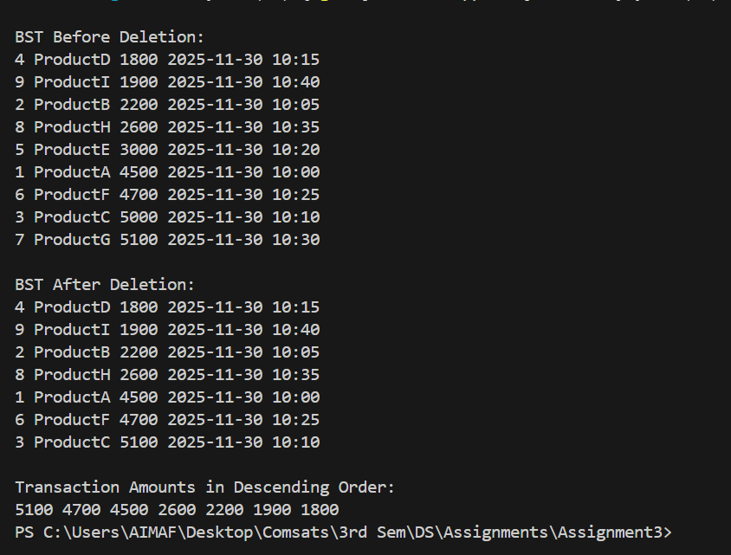

Question # 4

from intersection A to all others as quickly and reliably as possible. PART – A : THEORY 4.1 Emergency Broadcast Order Using BFS and DFS To deploy an emergency control update across all traffic intersections, the system must send signals from intersection A to all others as efficiently as possible. (a) Apply BFS starting from A and show: • Step-by-step queue updates • Visited nodes at each iteration • Final BFS visitation order (b) Apply DFS starting from A and show: • Step-by-step stack/recursive steps • Visited nodes at each iteration • Final DFS visitation order (c) Based on your results, justify which traversal (BFS or DFS) is more suitable for emergency broadcast where intersections must be reached using minimum number of edges. Give a clear explanation comparing both. 4.2 Minimum Spanning Tree Using Kruskal’s Algorithm Construct the MST for the road network using Kruskal's Algorithm. Show all required steps: • List all edges sorted by increasing weight • For each edge, state whether it is accepted or rejected (cycle check) • Show component/union-find updates • Draw or list the final MST • Calculate the total MST cost (sum of selected edge weights) 4.3 Shortest Travel Times Using Dijkstra’s Algorithm Apply Dijkstra’s Algorithm starting from intersection A. Show: • Node extracted in each step • Relaxation (update) steps for neighbors • Distance table after each iteration • Final minimum travel times from A to: B, C, D, E, and F PART – B : LAB / PROGRAMMING (C++) 4.4 Implement BFS and DFS (Lab) Write a C++ program to: • Build the graph using an adjacency list • Implement BFS and DFS starting from node A • Print step-by-step states (queue/stack and visited lists) • Display the final order for both BFS and DFS

CODE
#include <iostream>
#include <list>
#include <queue>
#include <vector>
using namespace std;

class Graph {
public:
int V; // number of vertices
list<int> *l; // adjacency list

Graph(int v) {
V = v;
l = new list<int>[V]; // create adjacency list for each vertex
}

void addEdges(int u, int v) { // undirected edge
l[u].push_back(v);
l[v].push_back(u);
}

// BFS traversal with step-by-step print
void bfs() {
vector<bool> vis(V, false);
queue<int> Q;
vector<int> bfsOrder;

Q.push(0); // start from node 0 (A)
vis[0] = true;

cout << "BFS Step-by-Step:\n";

while (!Q.empty()) {
int src = Q.front();
Q.pop();
bfsOrder.push_back(src);

// Print current visited nodes
cout << "Visited: ";
for (int i = 0; i < V; i++)
if (vis[i]) cout << char('A' + i) << " ";
cout << "\n";

// Print current queue
cout << "Queue: ";
queue<int> tmp = Q;
while (!tmp.empty()) {
cout << char('A' + tmp.front()) << " ";
tmp.pop();
}
cout << "\n";

cout << "Processing node: " << char('A' + src) << "\n\n";

// Traverse neighbors
for (int dest : l[src]) {
if (!vis[dest]) {
vis[dest] = true;
Q.push(dest);
}
}
}

// Final BFS order
cout << "Final BFS order: ";
for (int node : bfsOrder) cout << char('A' + node) << " ";
cout << "\n\n";
}

// DFS helper (recursive)
void dfsHelper(int src, vector<bool> &vis, vector<int> &dfsOrder) {
vis[src] = true;
dfsOrder.push_back(src);

// Print visited nodes at this step
cout << "Visited: ";
for (int i = 0; i < V; i++)
if (vis[i]) cout << char('A' + i) << " ";
cout << "\n";

cout << "Processing node: " << char('A' + src) << "\n\n";

for (int dest : l[src]) {
if (!vis[dest])
dfsHelper(dest, vis, dfsOrder);
}
}

// DFS traversal
void dfs() {
vector<bool> vis(V, false);
vector<int> dfsOrder;

cout << "DFS Step-by-Step:\n";
dfsHelper(0, vis, dfsOrder);

// Final DFS order
cout << "Final DFS order: ";
for (int node : dfsOrder) cout << char('A' + node) << " ";
cout << "\n\n";
}
};

int main() {
Graph g(5); // 5 intersections: A(0), B(1), C(2), D(3), E(4)

// Add edges
g.addEdges(0, 1); // A-B
g.addEdges(0, 2); // A-C
g.addEdges(1, 3); // B-D
g.addEdges(2, 4); // C-E

g.bfs(); // run BFS
g.dfs(); // run DFS

return 0;
}

OUTPUT
BFS Step-by-Step:
Visited: A
Queue:
Processing node: A

Visited: A B C
Queue: C
Processing node: B

Visited: A B C D
Queue: D
Processing node: C

Visited: A B C D E
Queue: E
Processing node: D

Visited: A B C D E
Queue:
Processing node: E

Final BFS order: A B C D E

DFS Step-by-Step:
Visited: A
Processing node: A

Visited: A B
Processing node: B

Visited: A B D
Processing node: D

Visited: A B C D
Processing node: C

Visited: A B C D E
Processing node: E

Final DFS order: A B D C E

Question # 5

PART – A : THEORY SECTION You are planning a power distribution network to connect power stations to multiple consumption points. The goal is to minimize the total distance of power lines, which affects the overall cost of the network (including terrain and infrastructure). The connections and distances between points are as follows: From To Distance (miles) A C 15 B C 20 B D 25 C E 30 D E 35 E F 40 E G 45 F G 50 Q1 (Theory): Graph Representation & Minimum Spanning Tree (a) Generate the Undirected Graph from the above information. Clearly label nodes and edge weights. (b) Using Kruskal’s Algorithm, construct the Minimum Spanning Tree (MST): • List all edges sorted by increasing weight. • Show step-by-step selection of edges: which edges are accepted or rejected (avoid cycles). • Draw the final MST and calculate the total distance of the MST. Deliverables: • Graph diagram • Edge list table (sorted by weight) • Stepwise Kruskal’s process • MST diagram with total distance PART – B : LAB / PROGRAMMING SECTION Q2 (Lab): Kruskal’s Algorithm Implementation in C/C++ Write a C/C++ program to: 1. Represent the network as an undirected weighted graph using an edge list or adjacency list. 2. Implement Kruskal’s Algorithm to find the Minimum Spanning Tree (MST). 3. Output: o Edges sorted by weight o Accept/reject decisions for each edge o Final MST edges and total distance Requirements / Restrictions: • Use structs or classes to represent edges and sets (for union-find). • Implement Union-Find (Disjoint Set) for cycle detection. • Include comments to explain key steps. • Display example output showing MST edges and total cost.

CODE

#include <iostream>
#include <vector>
#include <algorithm>
using namespace std;

// Structure to represent an edge
struct Edge {
char u, v;
int weight;
};

// Structure for Union-Find (Disjoint Set)
struct DisjointSet {
char parent[100];

// Initialize each node as its own parent
void makeSet(vector<char> nodes) {
for (char c : nodes)
parent[c] = c;
}

// Find representative (root) of a set
char find(char x) {
if (parent[x] == x)
return x;
return parent[x] = find(parent[x]); // path compression
}

// Union two sets
void unite(char x, char y) {
parent[find(x)] = find(y);
}
};

// Compare edges by weight
bool cmp(Edge a, Edge b) {
return a.weight < b.weight;
}

int main() {
// Create the graph (edge list)
vector<Edge> edges = {
{'A', 'C', 15},
{'B', 'C', 20},
{'B', 'D', 25},
{'C', 'E', 30},
{'D', 'E', 35},
{'E', 'F', 40},
{'E', 'G', 45},
{'F', 'G', 50}
};

// List of unique nodes
vector<char> nodes = {'A', 'B', 'C', 'D', 'E', 'F', 'G'};

// Sort edges by weight
sort(edges.begin(), edges.end(), cmp);

// Create disjoint set
DisjointSet ds;
ds.makeSet(nodes);

cout << "Edges sorted by weight:\n";
for (auto &e : edges)
cout << e.u << " - " << e.v << " : " << e.weight << endl;

cout << "\nKruskal's Algorithm Process:\n";

vector<Edge> mst; // store MST edges
int totalCost = 0;

for (auto &e : edges) {
char setU = ds.find(e.u);
char setV = ds.find(e.v);

if (setU != setV) {
// Accept the edge
mst.push_back(e);
totalCost += e.weight;
ds.unite(e.u, e.v);
cout << "ACCEPT: " << e.u << " - " << e.v << " (" << e.weight << ")\n";
} else {
// Reject edge
cout << "REJECT: " << e.u << " - " << e.v << " (" << e.weight << ") - forms cycle\n";
}
}

cout << "\nFinal MST Edges:\n";
for (auto &e : mst)
cout << e.u << " - " << e.v << " : " << e.weight << endl;

cout << "\nTotal MST Distance = " << totalCost << " miles\n";

return 0;
}

OUTPUT
